

Report for the first sprint

Yoana Kirolova Churkina | Front End Development | 2021

Contents

FEEDPULSE 3

Description of my webpage 4

PITI research 5

# FEEDPULSE

This is my FeedPulse that I had until the end of the First Sprint

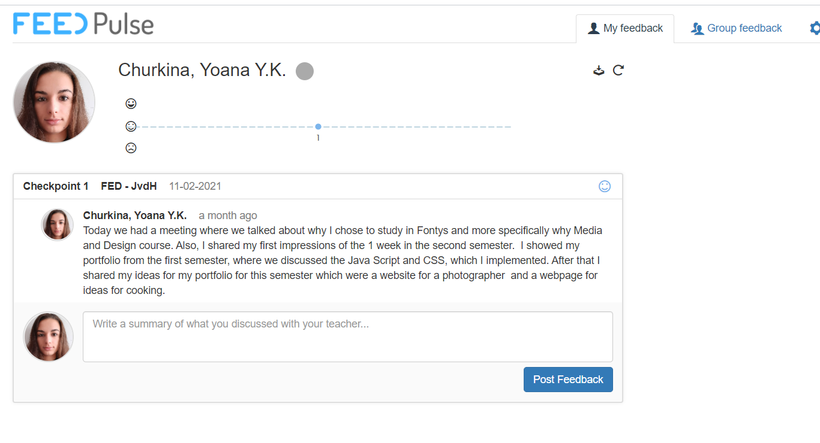

# Description of my webpage

My webpage is for sharing old recipes that I collect from my mother and my grandmother, so that’s why I decided to put these fonts, because I think that it makes the website looks cozier and more comfortable. That is like from the notebooks where we collect our recipes.

For the home page I implemented a video thus it looks more luxurious and more attractive for the person when he enters the site. Also, I think that with the section for the popular recipes is much easier to see which recipes are more liked from the others, so I put when it is hover to zoom the picture and to go to the recipe, but with the link I will implemented in the future. Another item that I put is the section about me, thus I want the person to know with who is communicate and if he is interested more about why I created the webpage and me, he can click the button and see it. I also made an animation where it is going to pull and give some cooking thoughts. For the future maybe I will put more items, which I wanted to have some animation that to make more comfortable for the person, who visits my webpage.

The other webpage is called “About” where I shared why I created the webpage and some information about me. I put an image for a background, which is blur and over it I made a box with some short description. I used some zooming and for this page.

I created a page for contact. There I put background picture and a form, which has the purpose people to share their opinion or recipes. It has buttons for submit and reset. The reset button is working, but the submit button is not, because it does not take the information that was introduced. So, I hope that in the future I can make it works properly.

The recipe page is made with different section, so the person to be more convenient to find exactly what he wishes. I implemented Java Script for the section, but inside (name of the recipes) are not working, this will be made in the future, because I want to find more comfortable way to store the data.

In conclusion, I believe that I have to implemented more items and Java Script in the webpage, so to look more finished and profecional.

# PITI research

1. Pick a topic:

I wanted to implement a transition and to understand more about the overflow. I wanted the picture to be zoomed.

1. Integrate:

I looked in the webpage how it is made by inspecting it and I see some items that I wanted to understand more how it is made, so that’s why I started investigating.

I find this as examples and explanation about the overflow properties.

<https://www.w3schools.com/cssref/pr_pos_overflow.asp>

Also, and for the transition I find information in w3schools.

https://www.w3schools.com/css/css3_transitions.asp

1. Try-out:

I saw the explanation and tried in w3schools where we can try it out. It worked there.

1. Integrate:

In the end I used in my page for the pictures in the homepage and it the about webpage.